

www.pandminc.com

Topic Area: Business (Website)

PROJECT REPORT AND EVALUATION

**Date:** 4th April, 2016  
 **Course Code:** DT211C-2  
 **Group:** *5*  
  
 **Team Members:** *Khurram Farooq, C16364286*

*Eoin Lynch,* C16310846

Zachary Kiernan, C16448986

**Table of Contents**

Introduction 1

System Requirements 1

Design Methods 3

Life Cycle Model 3

Cognitive Frameworks 3

Interaction Styles 4

Input & Output devices 6

Evaluation methods 6

Prototypes 7

Low Fidelity Prototype 7

Enhanced Low Fidelity Prototype 9

Evaluation of Low Fidelity Prototype 10

Medium Fidelity Prototype 10

Evaluation of Medium Fidelity Prototype 13

Conclusion 14

References 15

INTRODUCTION

We decided to pick the topic of Business and we wanted to work with a website that had a bad design and that would somehow relate to our field of study. Then we chose a computer software solutions company’s website which has a very bad interface design and frustrating layout of information because of these reasons we are making a better version of the website using out knowledge of HCI. We first looked at the initial design of the website and it was not appealing at all, we were sure that every user of the website would not like it, so we decided to change and make it better by redesigning the way the information was displayed. We made a couple of prototypes of the initial redesign, low and medium fidelity prototypes which helped us use mental models and metaphors to plan out what we were hoping the end product would be. We also evaluated them using Nielsen’s Heuristics Evaluation method.

SYSTEM REQUIREMENTS

There are many different types of requirements that are currently in the system, requirements such as functional requirements which describe how the system must behave and non-functional requirements which describes the characteristics that you want the system to have. Some functional requirements include most things on the page keep disappearing and reappearing which makes it confuse to detect the right information. This system behavior does not work at all, it isn’t attractive looking, and people will get annoyed while using it and some non-functional requirements include services such as their contact information (email and phone).

Our choice interface is focused on potential customers for P & M Computers Inc. This includes people of all demographics and ages. However, the choice interface would mainly focus on business owners who are looking for IT solutions for their company.

We have decided to make a few changes to the website interface such as getting rid of the long animations that start when the page loads and replacing them with simple blocks of text that don’t disappear. We would also make the page less clunky as it is very hard to navigate. The page is also monochrome which means that nothing on the page stands out too much. Using the 7-Stages of Action model I would completely get rid of all animations on the page as it interferes with the perceiving the state of the world stage of the 7-stages of action model. This is because the animations delay the user’s ability to judge if they clicked on the correct page and it can also confuse the user as to what is happening on the screen.

To analyze the current interface, the set of principles we will use will be the Principles of universal design. We will mainly look at the third, fourth and fifth principles of universal design. These are Simple and Intuitive use, Perceptible Information and Tolerance for error. P&M Computers Inc’s website has very little intuitive use. When the site loads the user is unsure of whether they should do anything as multiple animations are played out all over the webpage at once. In terms of perceptible information, the site gives the reader information, but it tends to quickly disappear quickly. There is also the issue of the user being presented with too much information at once for them to handle. For example, when the user navigates to the technology consulting page they are presented with a block of text. This is common throughout the website as it is devoid of any pictures or visual aids. Tolerance for error on this website is also very poor. For example there is no home button on the website, you must navigate to another section and you cannot go back to where you started off.

USE CASE DIAGRAM:

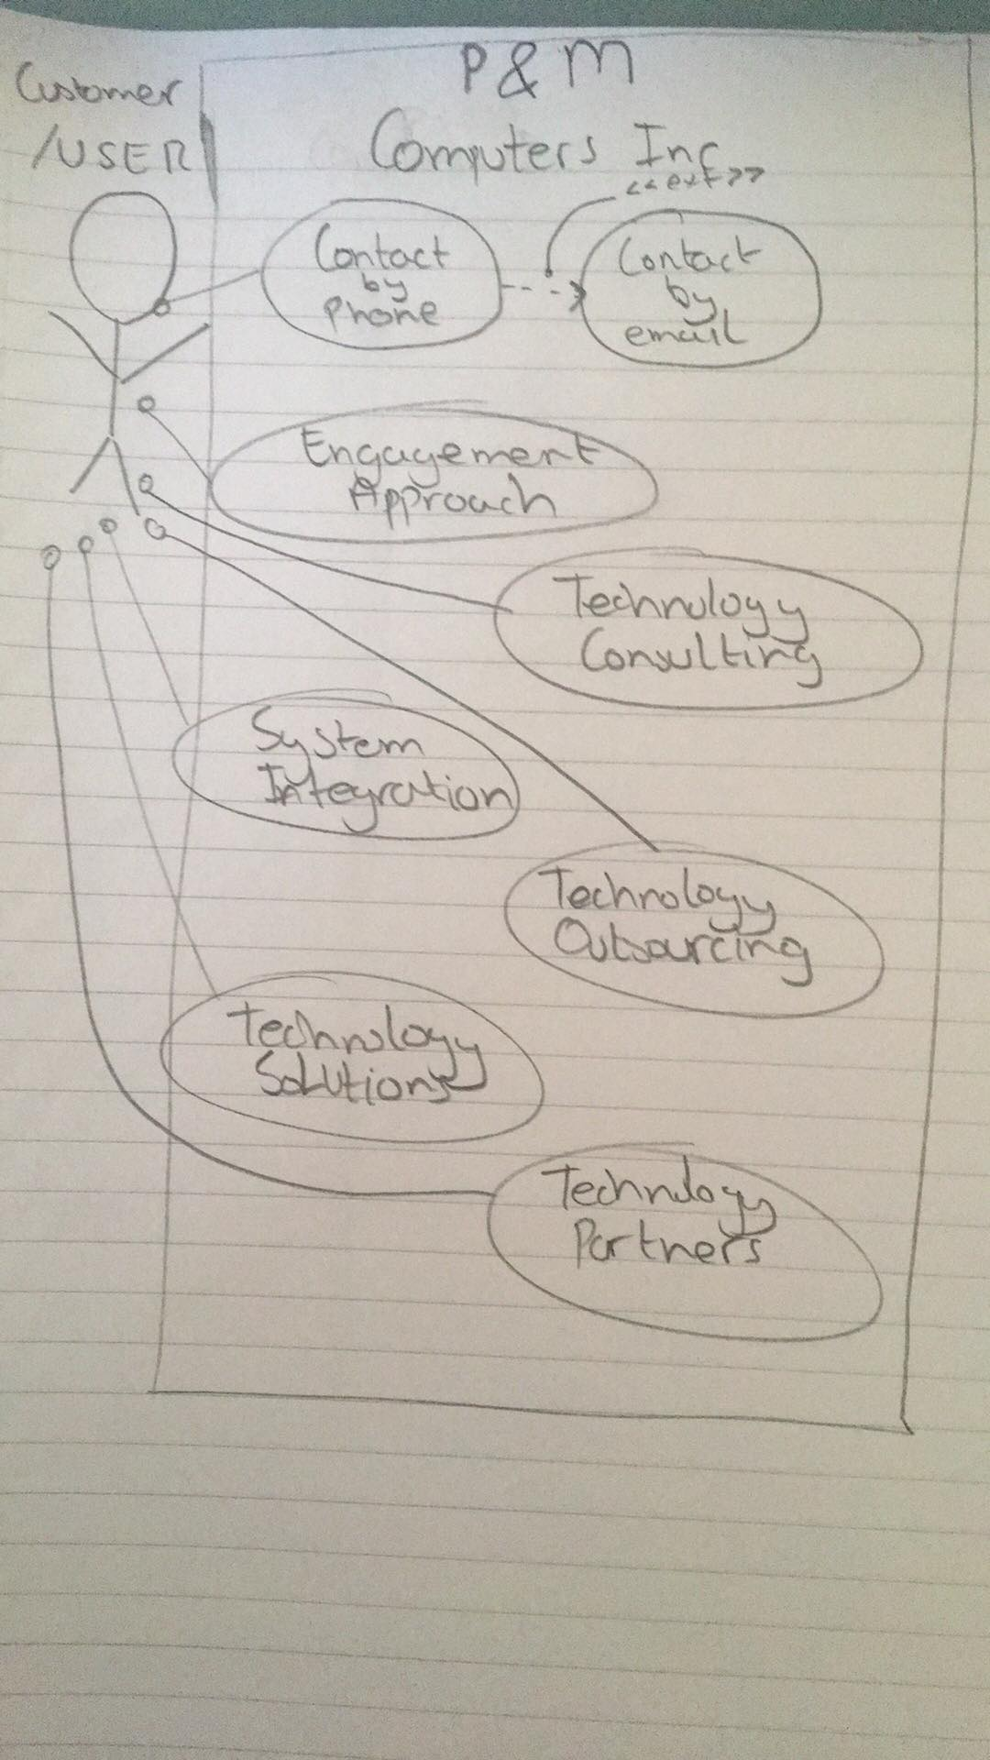

DESIGN METHODS

LIFE CYCLE MODEL

The process that is most suitable for the redevelopment of the system is the Star Lifecycle Model. This is the most suitable out of the others because it allows the designer different timeframes to work on each part of the system and also there is no specific order the designer must work or must follow. They are free to do whatever they want first. Thus, for example, a developer might start by experimenting with various design options and, in that process, learning more specific requirements of the project. For usability, the process ensures that users are positioned at the center of the development cycle and are encouraged to participate in any of the stages: at the beginning of the process, to help establish the system’s requirements and define their goals and needs; during prototyping, to ensure thorough testing under working conditions.

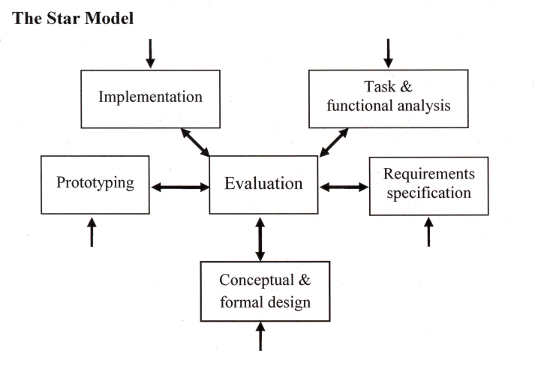

COGNITIVE FRAMEWORKS

The four cognitive processes include **Perception, Attention, Memory** & **Learning**. We have addressed **Perception** through mental models and metaphors. For example, the erroneous mental model teaches us that no matter how many times you repeat something that is going to take a specific amount of time, you cannot speed up the process by doing it again and again. In the case of our website, the same logic is followed, for instance if you click to contact the business by going to their contact page the speed of loading the web page is up to your internet speed in mega-bits per second, this will not decrease or increase if you press the contact page once or several times.

Addressed **Attention** because as I said before the home page when loading up as well as every other page on the website is very badly designed in regard to a user’s attention because as these are loading information is showing up randomly and one letter at a time and the size of the information changes too much during this transition. This is why the attention of the user will be lost because of this information overload and scattered information across each page of the website. This bad design of the site disengages the user and the user will lose attention during navigation of the site because they will be frustrated with the design, this is why we redesigned it so that this won’t happen. The users will be distracted by the constant moving and disappearing of the information on the webpage. The user needs to be able to navigate the site with minimal thinking and without any problems during browsing.

Addressed **Memory** because we wanted to fix the dull looking symbols on the webpage which linked to phone, email and the home page. This was addressed because it would be recognizable by all users of the system.

Addressed **Learning** because the coding techniques such as the color and the style were not attractive or suitable at all. The color of most of the information on the site was a light grey color on a white background. So, we changed this the headings to blue and the writing under each heading to black all on a white background. Other than that, the website can be used and user can become used to it through trial and error. We also provided an undo function for conflicting circumstances.

The above reasons are why the cognitive frameworks are applicable to this system as they will improve the overall usability experience.

INTERACTION STYLES

Interaction styles is the way users use a computer system. The first considerable is the GUI of the website, again the design was not good at all so we redesigned it so that each page of the website followed a certain order. Such as no disappearing of information and appearing of it one letter/symbol at a time. GUI needed a major reconstruction in terms of that but not in terms of the content of the website. From data entry we considered form filing for our system when a user needs to email the company they will be brought to a compose an email window where the usual information is required but the company’s email address is already filled in for convenience to the user. All the field labelled meanings are like any other email composition. This makes it easier for the users of the website comfortable as there are no major differences or anything that they may not have come across before.

*.*

INPUT AND OUTPUT DEVICES

The input and output devices we decided on were mouse and keyboard and a monitor as an output device. This is because they are the most accessible and easiest input output devices to design for. We would not put this exact design on a mobile device for a website because there would be too much information on such a small screen.

EVALUATION METHODS

We are going to evaluate our design by presenting it to some users to see how intuitive the design is and how long it takes them to understand the layout of the website. We would then document our findings by measuring how long it would take the user group to navigate the page and navigate to other pages.

The results of our evaluations found that our webpage was relatively easy for users to navigate. The simple layout made it easy for user to navigate and figure out what was happening on the page. One change we’d consider making in our medium fidelity prototype would be creating a sidebar on the webpage with information such as phone number and e-mail so that users can easily contact the webpage owners for more information on the company.

The evaluation method we used to evaluate our system was the Key Stroke Level model, we took into account what wastes a user’s time and what can enhance their experience. From our initial analyzation of the website showed us that the amount of time a user must spend to even start reading the information from each page was too long for a good user experience so through our redesign, we changed this and made it, so the user will have the best experience and will waste no time for the information to load up. This saved us a lot of time as the user could use all of the sites features and not have to wait for anything.

PROTOTYPES

LOW FIDELITY PROTOTYPE

We designed our low fidelity prototype in a way that we knew would better any user experience. We decided to change the way the information of the home page and other pages on the website would be displayed, we changed it to so that the information would not appear/disappear quickly confusing the user.

The cognitive process we addressed in our prototype was mainly attention. Addressed **Attention** because as I said before the home page when loading up as well as every other page on the website is very badly designed in regards to a user’s attention because as these are loading information is showing up randomly and one letter at a time and the size of the information changes too much during this transition. This is why the attention of the user will be lost because of this information overload and scattered information across each page of the website. This bad design of the site disengages the user and the user will lose attention during navigation of the site because they will be frustrated with the design, this is why we redesigned it so that this won’t happen. The users will be distracted by the constant moving and disappearing of the information on the webpage. The user needs to be able to navigate the site with minimal thinking and without any problems during browsing.

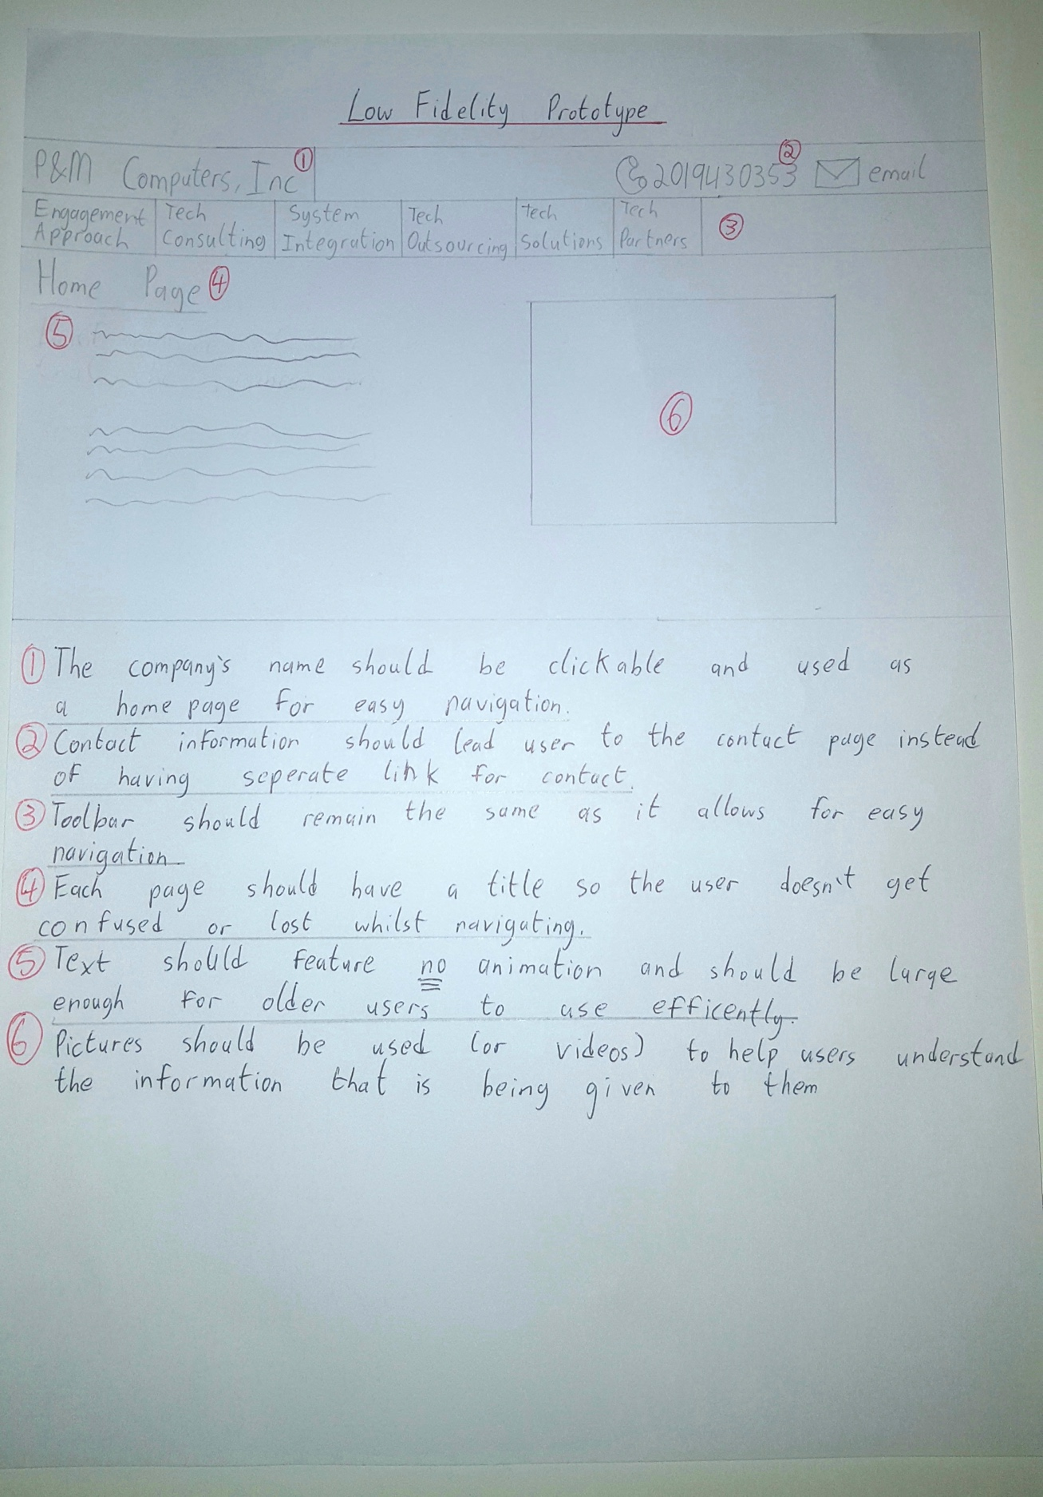

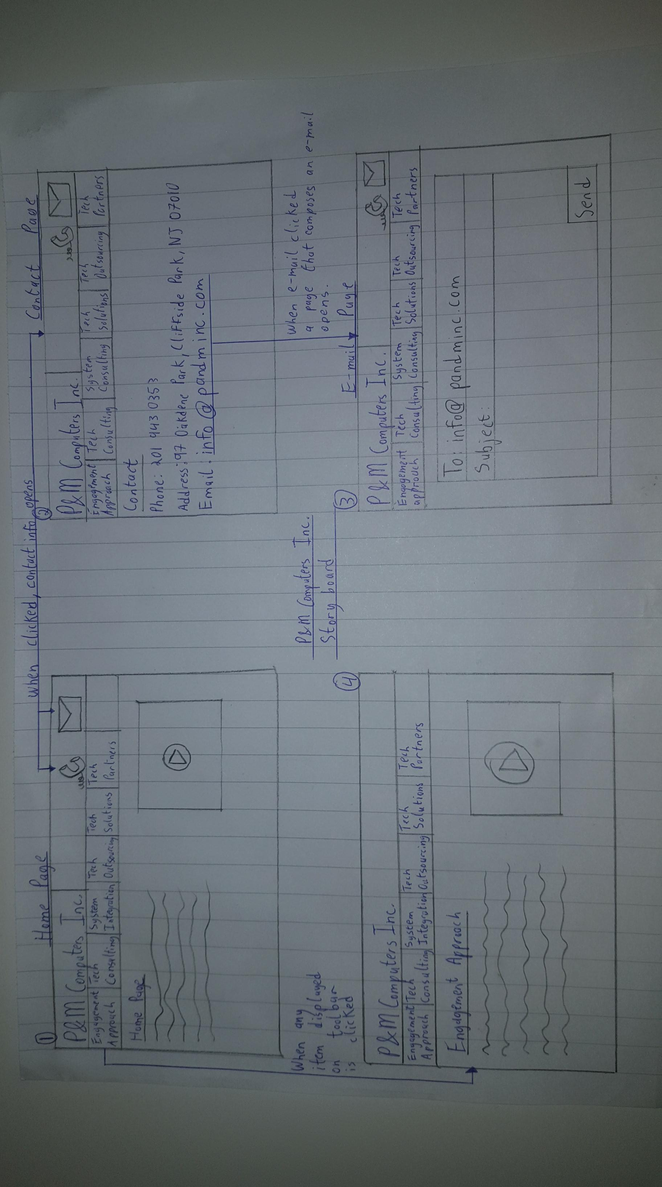ENHANCED LOW FIDELITY PROTOTYPE

In our more comprehensive low fidelity prototype we decided to change the contact pages from the website, we made it so that the interface is user friendly and recognizable by showing all the important information at the right time and the right place. This will make the user get in contact with the company easily and without confusion.

|  |  |
| --- | --- |
|  |  |
|  |  |
|  |  |

EVALUATION OF ENHANCED LOW FIDELITY PROTOTYPE

We evaluated again using the Key Stroke Level model which helped reduce the time it takes for the user to navigate the site and find the information as easily as possible. We also used the Nielsen’s Heuristics evaluation method to help us see and resolve any issues we had with the interface. After doing that, we had a more consistent design with easily understandable information using recognizable words and phrases. From the evaluation, we realized that there are not any more significant changes we can make to the website itself.

MEDIUM FIDELITY PROTOTYPE

Our group used Pencil to create a medium fidelity prototype. This prototype contains working links and spaces that are reserved for text and video resources. We also included a page for composing e-mails. The text and video boxes on each page are placeholders for text and video resources that the webpage would use.

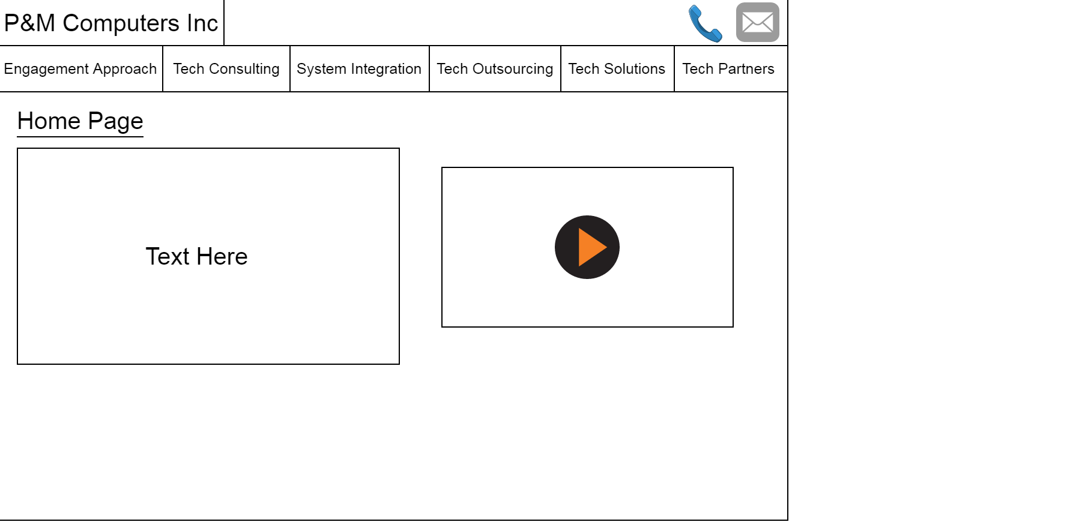

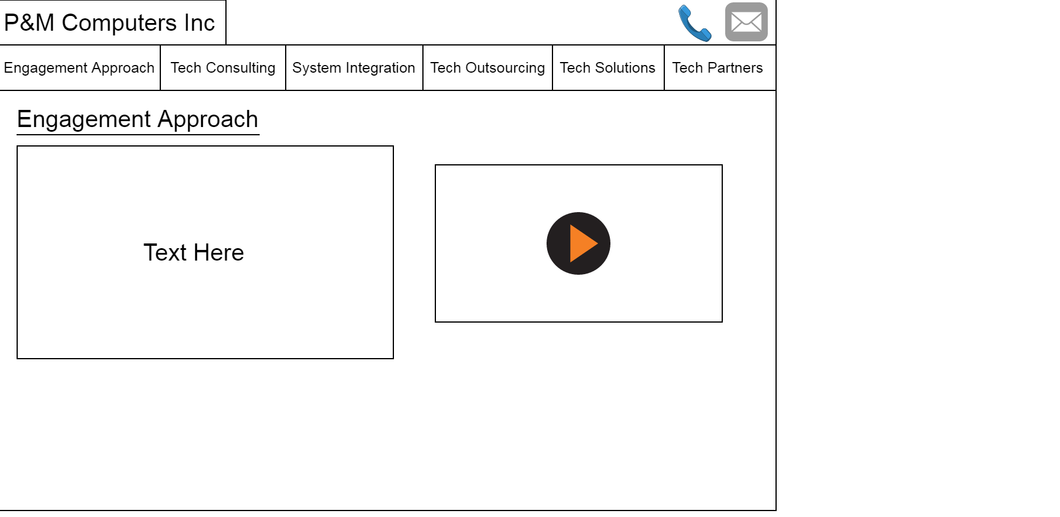

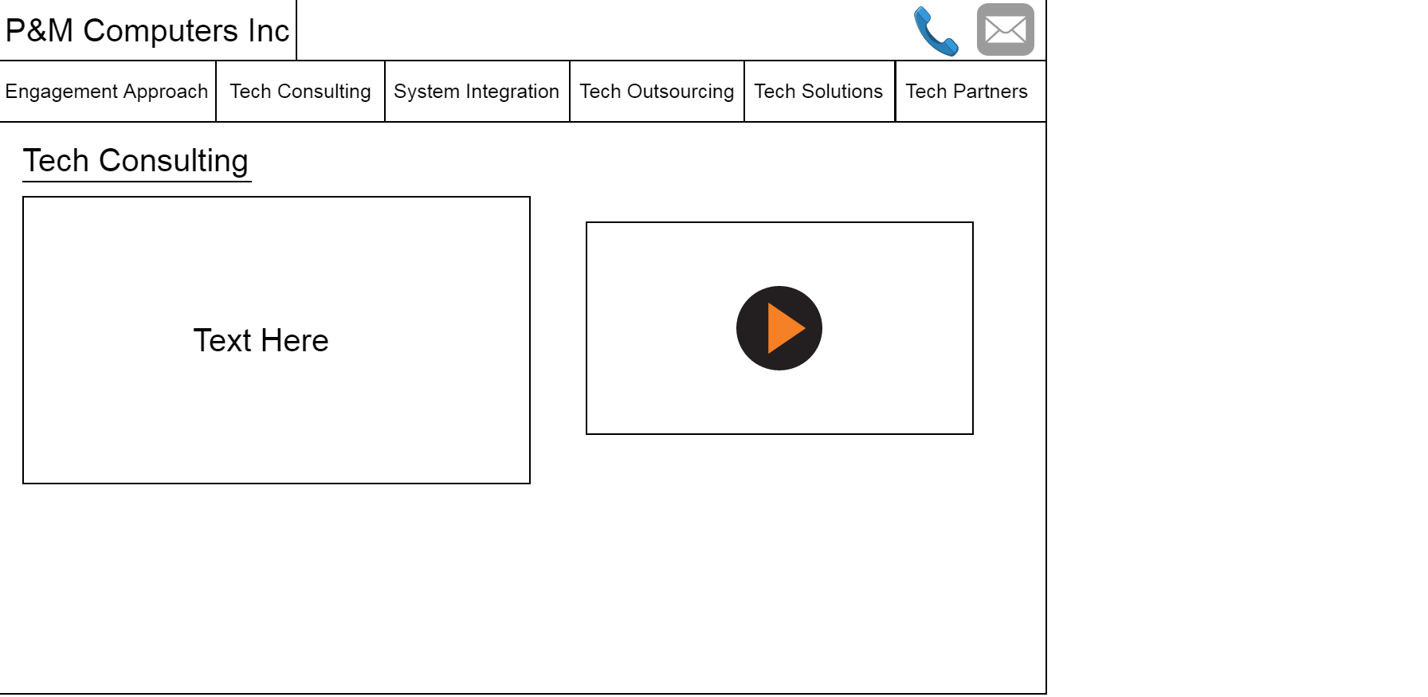

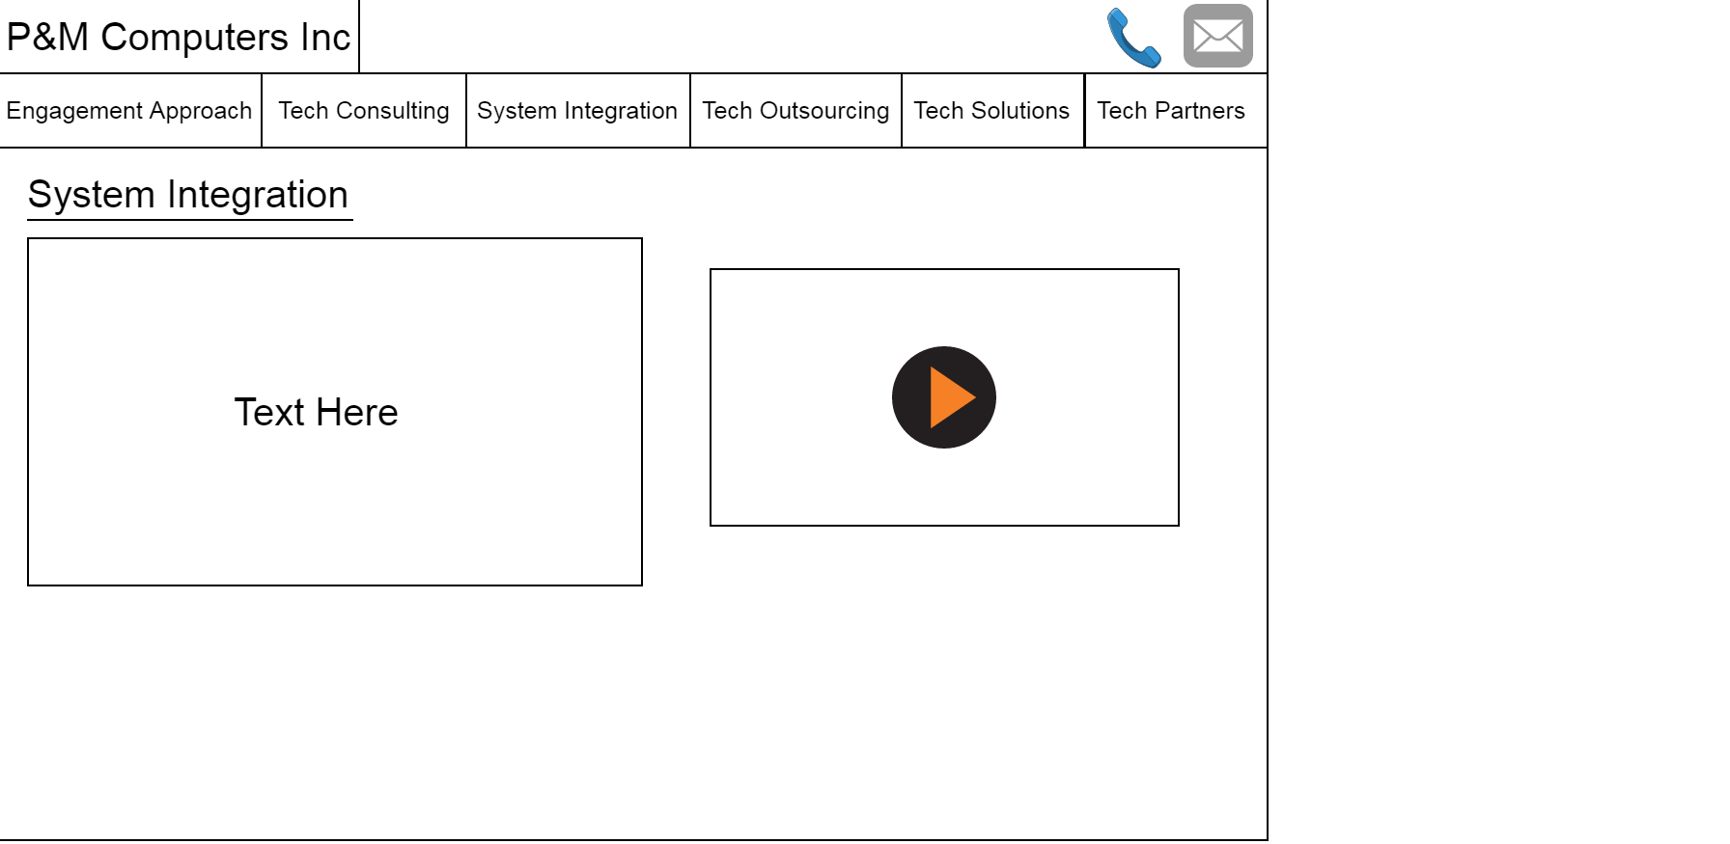

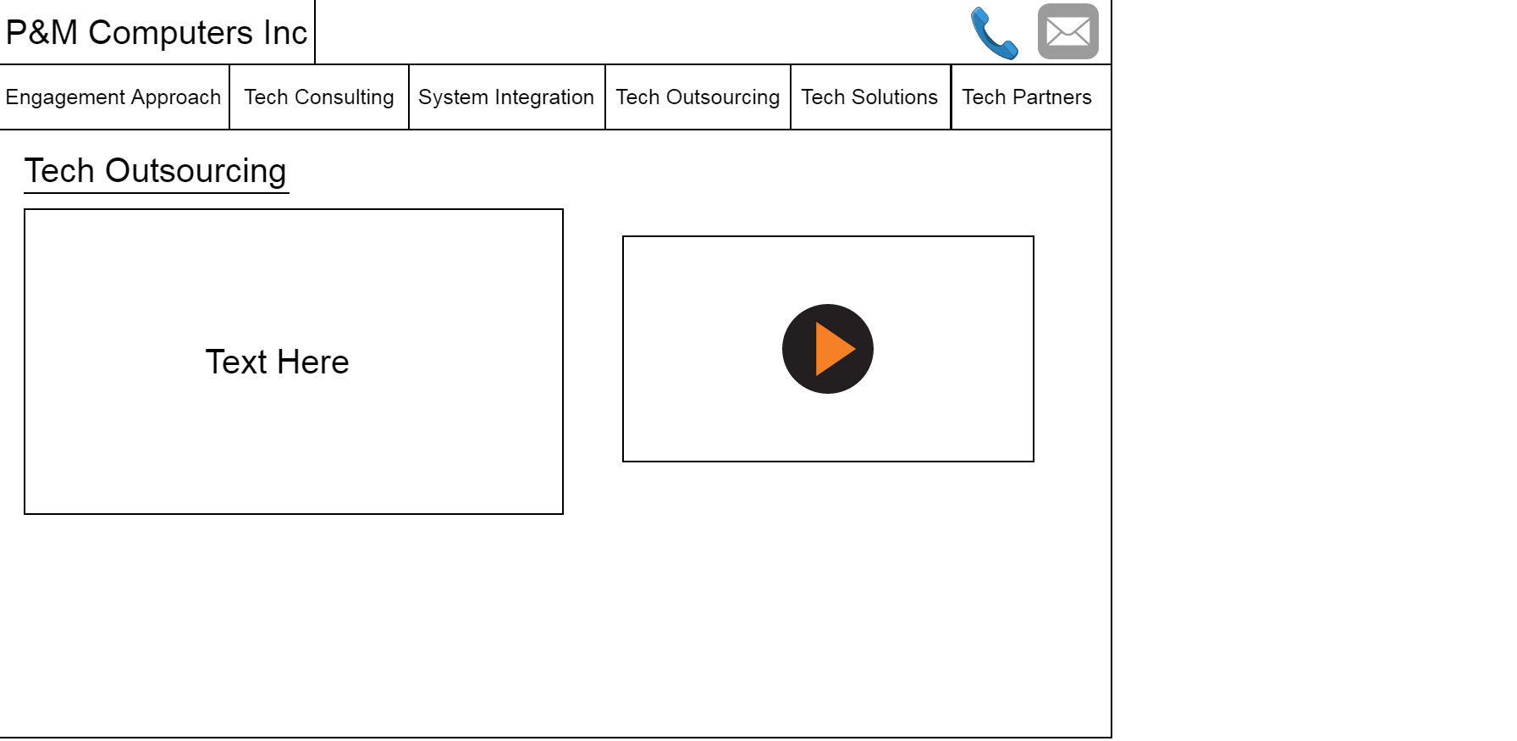

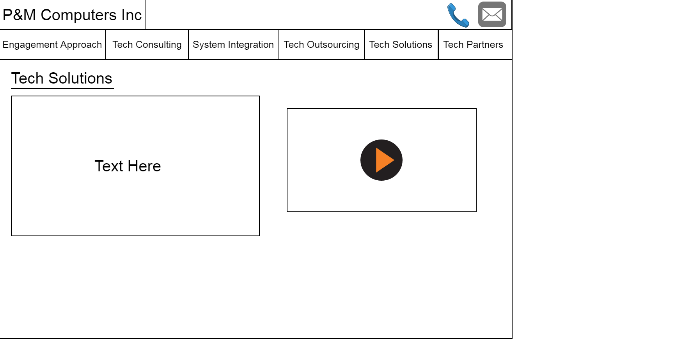

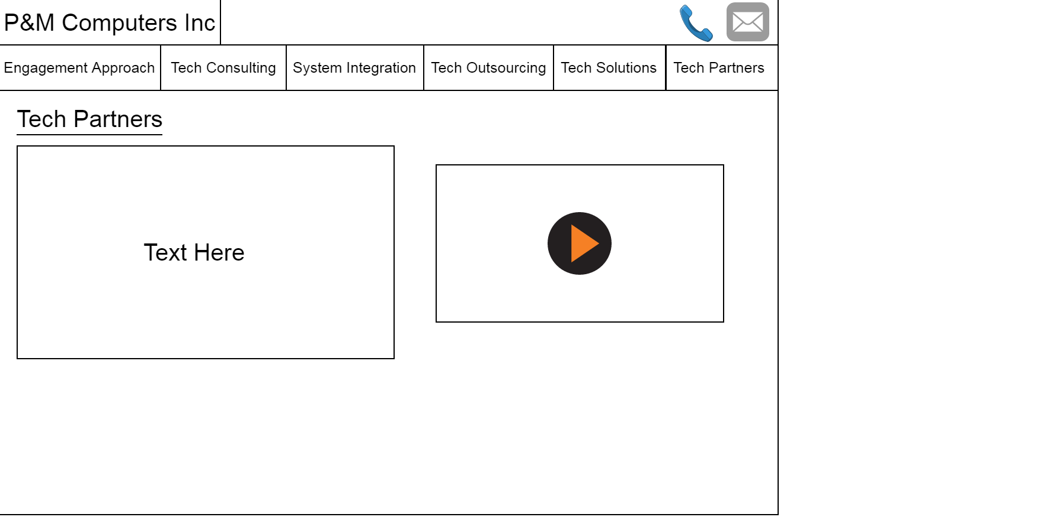

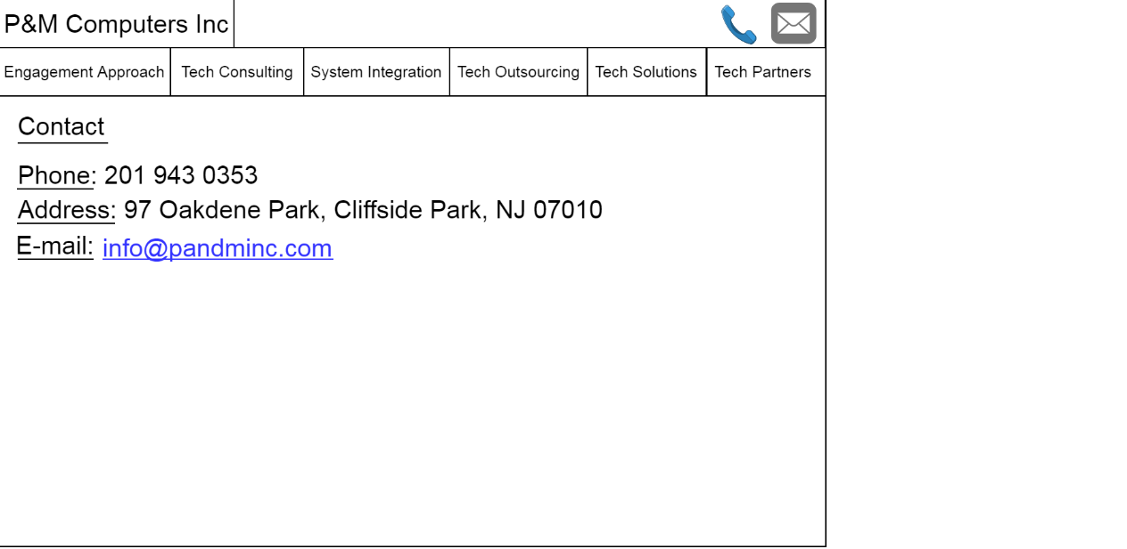

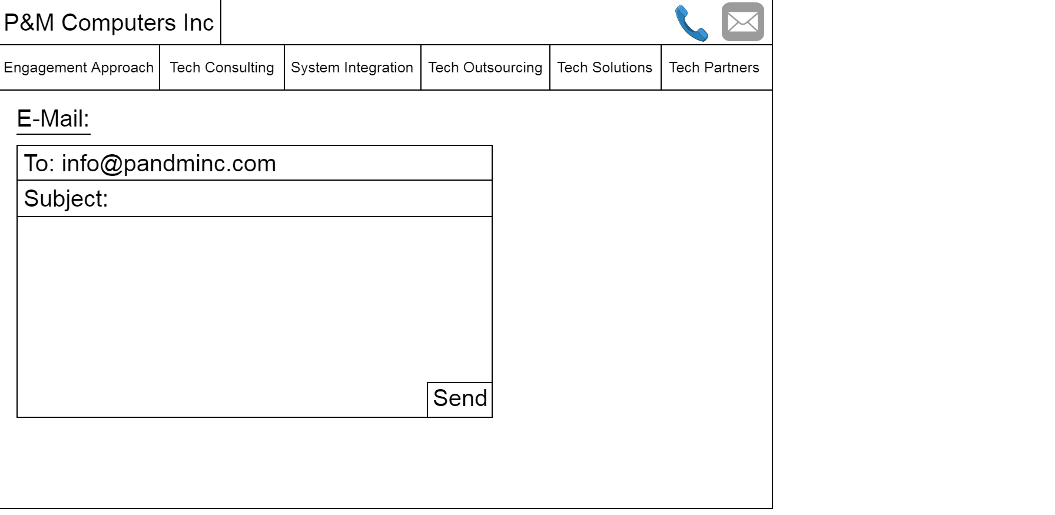

EVALUATION OF MEDIUM FIDELITY PROTOTYPE

To evaluate the medium fidelity prototype, we had other people in the class use the website. We asked them how easy the site was to navigate and made modifications based on our findings. We also measured how efficient our site was using the Usability guidelines. Using these guidelines, we found that users found the minimalistic layout of the website very easy to navigate and locate the different pages on the webpage.

CONCLUSION

In conclusion, our group learned a lot about human computer interaction through working on this assignment. We learned a lot about system requirements, design methods, input and output devices and the different mental frameworks. As a group we also became more efficient at producing prototypes. The new webpage that was created was also a lot more efficient and easy to navigate than the older webpage that is currently online. The different prototypes we created also helped us comprehend the concepts behind the human computer interaction module.REFERENCES

1. *We used the lecture notes found in the Human Computer Interaction* module on webcourses.